Arab American University
Faculty of Engineering and Information Technology
Computer Systems Engineering
SENIOR PROJECT I

Cube Mind
(Rubik's Cube solver)

2025/2026

Supervised by: Dr. Tareq Zanoon

Computer Systems Engineering Dept.
Submitted in partial fulfillment of the requirements of B.Sc. Degree in Computer Systems Engineering

July 2025

Students Statement

We, the undersigned students, certify and confirm that the work submitted in this project report is entirely our own and has not been copied from any other source. Any material that has been used from other sources has been properly cited and acknowledged in the report.

We are fully aware that any copying or improper citation of references/sources used in this report will be considered plagiarism, which is a clear violation of the Code of Ethics of the Arab American University.

Mohammad Atiyeh (202112724) | Ahmad khaldy (202110946)
Loai Hamamdeh (201811792)

Supervisor Certification

This to certify that the work presented in this senior year project manuscript was carried out under my supervision, which is entitled:

"Cube Mind"

Mohammad Atiyeh (202112724) | Ahmad khaldy (202110946)
Loai Hamamdeh (201811792)

I hereby that the aforementioned students have successfully finished their senior year project and by submitting this report they have fulfilled in partial the requirements of B.Sc. Degree in Engineering.

I also, hereby that I have read, reviewed and corrected the technical content of this report and I believe that it is adequate in scope, quality and content and it is in alignment with the ABET requirements and the department guidelines.

Dr. Tareq Zanoon,

ACKNOWLEDGMENT
We would like to express our sincere gratitude and appreciation to all those who contributed to the successful completion of this senior project.
First and foremost, we extend our deepest thanks to Dr. Tareq Zanon, our project supervisor, for his invaluable guidance, continuous support, and expert advice throughout the development of this project. His mentorship and constructive feedback were instrumental in shaping our work and ensuring its successful completion.
We are grateful to the Arab American University and the Computer System Engineering Department for providing us with the necessary academic environment, resources, and facilities that enabled us to pursue this challenging and rewarding project.
We would like to acknowledge the collaborative efforts of our team members: Mohammad Atteyah, Ahmad Khaldy, and Loay Hamamdi. Their dedication, technical expertise, and teamwork were essential to overcoming the various challenges encountered during the development of our Rubik's cube solving robot.
We extend our heartfelt appreciation to our parents for their unwavering support, encouragement, and patience throughout our academic journey. Their belief in our abilities and their continuous motivation have been a source of strength and inspiration.
Finally, we thank everyone who directly or indirectly contributed to the success of this project. Their support and encouragement have made this achievement possible.

ABSTRACT
This project presents the design and implementation of an autonomous robot capable of solving a 3×3 Rubik's cube using Kociemba's algorithm. The primary objective of this work is to integrate and apply the knowledge and skills acquired throughout our Computer System Engineering studies while exploring new technical competencies in robotics, computer vision, and algorithm implementation.
The system consists of a Raspberry Pi as the main processing unit, coupled with cameras for cube state detection, motors for mechanical manipulation, and supporting structural components. The robot operates by first scanning and analyzing all six faces of the Rubik's cube using computer vision techniques to determine the current scrambled state. Once the cube configuration is captured and processed, the system applies Kociemba's algorithm to calculate an optimal solution sequence. The robot then executes the solution by systematically rotating the cube faces using precisely controlled motors until the puzzle is completely solved.
The project demonstrates the integration of multiple engineering disciplines, including embedded systems programming, computer vision, mechanical design, and algorithmic problem-solving. Developed using Python programming language, the system showcases the practical application of theoretical concepts learned during our academic program. This work contributes to the field of educational robotics and serves as a comprehensive demonstration of autonomous puzzle solving capabilities, bridging the gap between algorithmic theory and practical robotic implementation.

TABLE OF CONTENTS

LIST OF FIGURES iii
LIST OF TABLES iv
LIST OF SYMBOLS AND ABBREVIATIONS ….. v
1 CHAPTER 1: INTRODUCTION 1
1.1 Problem Statement and Purpose 1
1.2 Project and Design Objectives 1
1.3 Intended Outcomes and Deliverables 1
1.5 Summary of Report Structure 1
2 CHAPTER 2: BACKGROUND 2
2.1 Overview 2
2.2 Related Work 2
3 CHAPTER 3: METHODS AND MATERIALS 3
3.1 System Design and Components 3
3.2 Design Specifications, Standards and Constraints 3
3.3 Design Alternatives 3
3.4 System Analysis and Optimization 3
3.5 Simulation and/or Experimental Test 3
4 CHAPTER 4: RESULTS AND DISCUSSIONS 4
4.1 Results 4
4.2 Discussions 4

5 CHAPTER 5: PROJECT MANAGEMENT 5
5.1 Tasks, Schedule and Milestones 5
5.2 Resources and Cost Management 5
5.3 Lessons Learned 5

6 CHAPTER 6: IMPACT OF THE ENGINEERING SOLUTION 6
6.1 Economical, Societal and Global 6
6.2 Environmental and Ethical 6
6.3. Other Issues 6

7 CHAPTER 7: CONCLUSIONS AND RECOMMENDATIONS 7
7.1 Summary of Achievements of the Project Objectives 7
7.2 New Skills and Experiences Learnt 7
7.3 Recommendations for Future Work 7
REFERENCES 8

APPENDICES 9
Appendix A: 9
Appendix B: 9
Appendix C: 9

LIST OF FIGURES
Figure Page

Fig. 1. AI RUBICK CUBE SOLVER 5
Fig. 2. ROBOT SOLVERS RUBIC’S CUBE 6
Fig. 3. CUBEMOSTOR 8
Fig.4. SOLVING THE RUBIK’S CUBE WITH DEEP REINFORCEMENT LEARNING AND SEARCH 9
Fig.5. WORKFLOW FLOWCHART 14
Fig.6. USECASE DIAGRAM 15
Fig.7. SEQUENCE DIAGRAM 15
Fig.8. APPROXIMATE IMAGE FROM ABOVE 17
Fig.9. APPROXIMATE SIDE VIEW 1 18
Fig.10. APPROXIMATE SIDE VIEW 2 19
Fig.11.APPROXIMATE IMAGE FROM BELOW 20
Fig.12. RASPBERRY PI 21
Fig.13. CAMERAS 21
Fig.14. SEVRO MOTORS 22
Fig.15. BASE 22

LIST OF TABLES
Table Page

Table. 1. Related works and ours table show 10-12

LIST OF SYMBOLS AND ABBREVIATIONS
This is where you should put all the symbols used and abbreviations (must be sorted). It is stored in a table format same as the table of contents. Use inserts a row to add more entries….etc

LIST OF SYMBOLS
LIST OF ABBREVIATIONS
STEM | • Science  • Technology  • Engineering  • Mathematics
BFS | Breadth First Search
CNN | Convolutional Neural Network
CFOP | CFOP: Cross, F2L (First Two Layers), OLL (Orientation of the Last Layer), PLL (Permutation of the Last Layer)
DFS | Depth First Search

- CHAPTER 1: INTRODUCTION
This project focuses on the design and implementation of an autonomous robot capable of solving a 3×3 Rubik's cube, integrating multiple engineering disciplines including computer vision, mechanical design, embedded systems, and algorithmic implementation. The challenge lies in creating a robust physical system capable of precise cube manipulation and reliable state detection while applying the knowledge gained throughout our Computer System Engineering studies.
We chose Kociemba's algorithm because it finds efficient solutions with a low number of moves, often under 21 steps. It's fast, well documented, and works well with the standard 3×3 cube structure. This makes it ideal for real time solving in a robotic system, where fewer moves mean less mechanical complexity and faster results. However, implementing this algorithm in a physical robotic system presents several significant technical challenges. Color detection requires accurately identifying the cube's colors using a camera under different lighting conditions, which can be particularly difficult. Mechanical control involves designing a stable and precise system to rotate the cube faces without slipping or misalignment. Integration challenges arise from ensuring that hardware components including motors and cameras work seamlessly with software systems encompassing vision processing and algorithm implementation in real time. Additionally, calibration requires precise alignment of the camera, cube positioning, and mechanical arms for consistent operation.
The scope of this project encompasses the complete design and implementation of an autonomous Rubik's cube solving robot. The main objectives include developing a robust computer vision system for accurate cube state detection, implementing Kociemba's algorithm for efficient solution generation, designing and constructing a reliable mechanical manipulation system, integrating all components using a Raspberry Pi based control system, and demonstrating successful autonomous cube solving capabilities. The expected outcomes include a fully functional robot capable of consistently solving scrambled 3×3 Rubik's cubes, comprehensive documentation of the design and implementation process, and demonstration of the practical application of Computer System Engineering principles in a real world robotics project.

  - Problem Statement and Purpose
This project addresses the technical challenge of designing and implementing an autonomous robotic system that can detect, analyze, and solve a scrambled 3×3 Rubik's cube without human intervention. The system must integrate computer vision for cube state recognition, Kociemba's algorithm for solution computation, and precise mechanical control for cube manipulation using Raspberry Pi based embedded systems.
The purpose of this project is to demonstrate comprehensive application of Computer System Engineering principles through a complex, multi-disciplinary robotics implementation. This project provides practical experience in embedded systems programming, computer vision, mechanical design, and real time algorithm implementation, directly preparing students for industry challenges requiring integration of hardware and software systems. The project serves as an educational platform that bridges theoretical knowledge with practical engineering skills, contributing to STEM education by showcasing how multiple engineering disciplines collaborate to achieve autonomous system functionality.

  - Project and Design Objectives
- Design and build a robotic hardware system that can house, monitor, and rotate all Rubik's cube sides.

- Solve a standard 3×3 Rubik's cube in 30 seconds or less from initial cube scanning to completion.
- Achieve a minimum 90% success rate in correctly solving randomly scrambled 3×3 Rubik's cube
- Color Detection Accuracy: The computer vision system shall accurately identify all six cube face colors with 95% accuracy under standard indoor lighting conditions.
  - Intended Outcomes and Deliverables
We intend to build a Rubik’s Cube Solving Robot, an embedded mechatronic system capable of automatically solving a standard 3x3 Rubik’s Cube. The robot will consist of a mechanical structure operated by motors to manipulate the cube, a software interface to receive or detect the cube's state, and a solving engine that applies the Kociemba algorithm to determine the optimal move sequence. The key outcome of this project is to demonstrate how embedded systems, control algorithms, and mechanical design can be integrated into a fully automated problem solving machine. This system aims to showcase the practical application of engineering principles in robotics, optimization, and real time control.
This project is intended as a learning platform and proof of concept for more advanced robotic manipulation systems. We aim to present it at engineering exhibitions and hope to inspire further development in educational robotics or puzzle solving automation.

  - Summary of Report Structure
This report is organized into seven chapters. The second chapter provides an overview of the project and discusses related work in the field. The third chapter focuses on the system design and its components, covering design specifications, standards, constraints, design alternatives, system analysis, optimization, and simulation or experimental testing. Chapter four presents and analyzes the project results. Chapter five details the management aspects of the project, including time management, cost management, and lessons learned. Chapter six examines the project's costs, production considerations, and its social and environmental impact. Finally, chapter seven reflects on the project goals achieved, evaluates the level of success, highlights the skills and experiences gained, and offers recommendations for future work.

- CHAPTER 2: BACKGROUND
  - Overview
The Rubic’s Cube was invented in 1974, it is a three-dimensional puzzle that has fascinated millions around the world, competitions are now held to solve it, attracting people of all ages to try to solve it. Solving the cube independently using robots requires the integration of multiple engineering disciplines, including computer vision, mechanical design, embedded system, and algorithm optimization. The challenge lies in creating a system capable of accurately determining the state of the cube, calculating the optimal solation and performing precise mechanical operations to efficiently solve the puzzle.
We used the Kociemba’s algorithm, a two- phase algorithm that significantly reduces the cube’s solution space, enabling the puzzle to be solved efficiently with the fewest moves, this algorithm is widely known for its balance between speed and optimal solution, making it ideal for robotic applications.
  - Related Work

AI Rubick Cube solver
This is the first project related to our project and this project uses artificial intelligence to solve the Rubik’s Cube puzzle automatically, this project relies on algorithm like BFS, but instead, we worked on the Kociemba’s algorithm because it’s faster and better. This project would require thousands of moves to solve the cube, whereas ours solves the cube in 21 moves or less, this project relied on CNN, but we used cameras.
The algorithm used in this project:
The Cube GitHub project, Ai Rubik's cube solver, demonstrated a learning-based approach to solving a 3x3 Rubik's cube by predicting the next move from the current state of the cube. The cube is internally represented as a 6x3x3 3D ​​matrix, where each element represents a specific color on the cube's surface. The project relies on simulating the cube's 18 orientations (rotations of each of its two faces) using NumPy operations.

A massive dataset is created by applying shuffles to the cube, then using the Kociemba algorithm to calculate the first deep move in the solution for each shuffled state. Each state is then classified according to the first move in the solution chain. This data is used to train a deep neural network consisting of several dense layers. The network receives an input of 54 values ​​(representing the flat state of the cube) and produces a single classification of 18 attractors. The model is trained using the Adam algorithm and a Sparse Categorical Cross entropy loss.

When the model is run, it is used to predict the next move to be made at each step, and one more orientation is performed until the cube is solved or the maximum number of orientations is reached. The model achieves a perfect fit of 70% on the validation set and performs well on small cases (those characterized by a small number of achievements), but its performance declines on complex data due to the limitations of advanced diversity.

In contrast, traditional solutions, such as those using the Kociemba farming algorithm (such as the Bulgarian Python library Kociemba's), rely on mathematical positive algorithms that provide novel or near-novel solutions in terms of the number of visits. This algorithm divides the solution into two stages: the first goal is to transform the cube into a constrained, solvable state, and the second goal is to fully solve it. This can be a deterministic and accurate method for the New Delhi calculation, as it continues to reach a significant solution for the cube state.

Thus, it can be argued that the AI based algorithm provides a solution based on learning and generalization from data, but it may be inaccurate in complex cases. Kociemba's algorithm, on the other hand, guarantees fast and accurate solutions without the need for learning, but it does not have the adaptability or generalization capabilities of innovative research. [1]
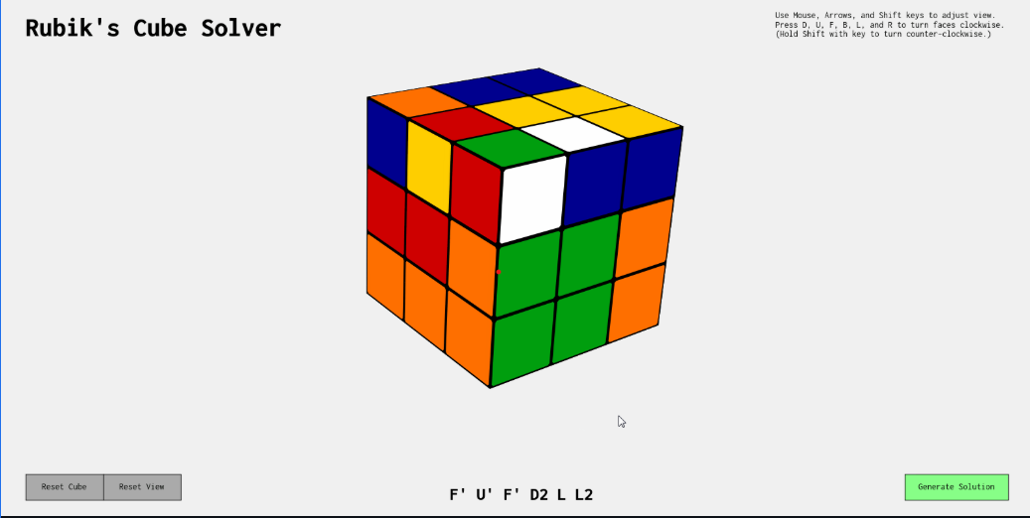
Figure 1 AI RUBICK CUBE SOLVER

Robot solves Rubic’s cube
The second project is a physical robot (not just a software simulation) that solves a Rubic’s Cube using motors and sensors. This project also aims to solve a Rubik’s Cube automatically and relies on a camera and motors, it’s similar to our project.
This project robot implemented by students from the University of the Pacific, represents an advanced model that combines several technical fields, including mechanical design, computer vision, and artificial intelligence. The robot's exoskeleton was designed using 3D printing, with a base that holds mechanical arms equipped with precise servo motors capable of grasping the cube and rotating its eighteen basic faces (in both directions). The cube's state recognition mechanism relies on a computer vision system that uses an onboard camera to capture images of each face. The images are analyzed using image processing algorithms via libraries such as OpenCV, where each color is classified and precisely positioned within the cube's grid. This data is then converted into a digital representation of the cube's entire state (usually in the form of a text string or a matrix representing colors by position) and passed to the system's artificial intelligence module. This component, programmed by a student using Python, implements a cube-solving algorithm, likely inspired by Kociemba's two-stage algorithm. After calculating the sequence of movements, commands are sent to a microcontroller, which directs the motors to execute the movements accurately and at high speed. In the experiments, the robot was able to solve the cube in a record time of approximately 3.03 seconds using only 18 movements. The final solution is displayed on a digital screen or via flashing lights to indicate the completion of the process. What distinguishes this project is that the students built the entire system from scratch within one academic year, from 3D modeling and structural fabrication to programming and intelligent control. This demonstrates a deep understanding of the integration of mechanical systems with artificial intelligence technologies and demonstrates the potential of such systems for broader applications such as robotic arms, educational robots, and automated systems in the industrial field. [2]
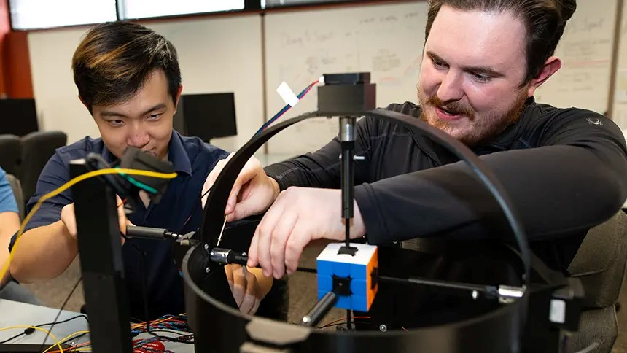
Figure 2 ROBOT SOLVES RUBIC’S CUBE

CubeMoster
The third project is very similar to ours, solving the cube using several algorithms, such as CFOP, DFs and Kociemba’s, which we will use in our project. The main difference between the two projects is that they use an Arduino, a raspberry, while our project does not use an Arduino.
What distinguishes Cube Master from other similar projects is the ability to customize the solution method to suit the user's needs. The system supports four different algorithms: the Beginner's Method, suitable for new learners; CFOP, adopted by professional players; the Kociemba algorithm, known for its high efficiency in reducing the number of moves; and finally, the Deep Search (DFS) algorithm, which includes a tutorial mode that guides the user through each step of the solution process.

Interactively, the system features a simple user interface that includes an LCD screen that displays the time taken, the number of moves made, and other statistical information, as well as a joystick that allows navigation between different modes. These features make Cube Master an effective educational tool, capable of combining practicality with fun learning.

In terms of performance, Cube Master has achieved significant progress compared to similar projects, thanks to the use of advanced computer vision techniques that enable automatic recognition of the initial state of the cube without manual intervention. This advancement has reduced the solution time to just a few seconds, compared to the traditional average of 40 to 60 seconds. The combination of speed, accuracy, and interactive learning capabilities makes Cube Master an ideal platform for students, developers, and users looking to explore AI applications in a real world environment. [3]

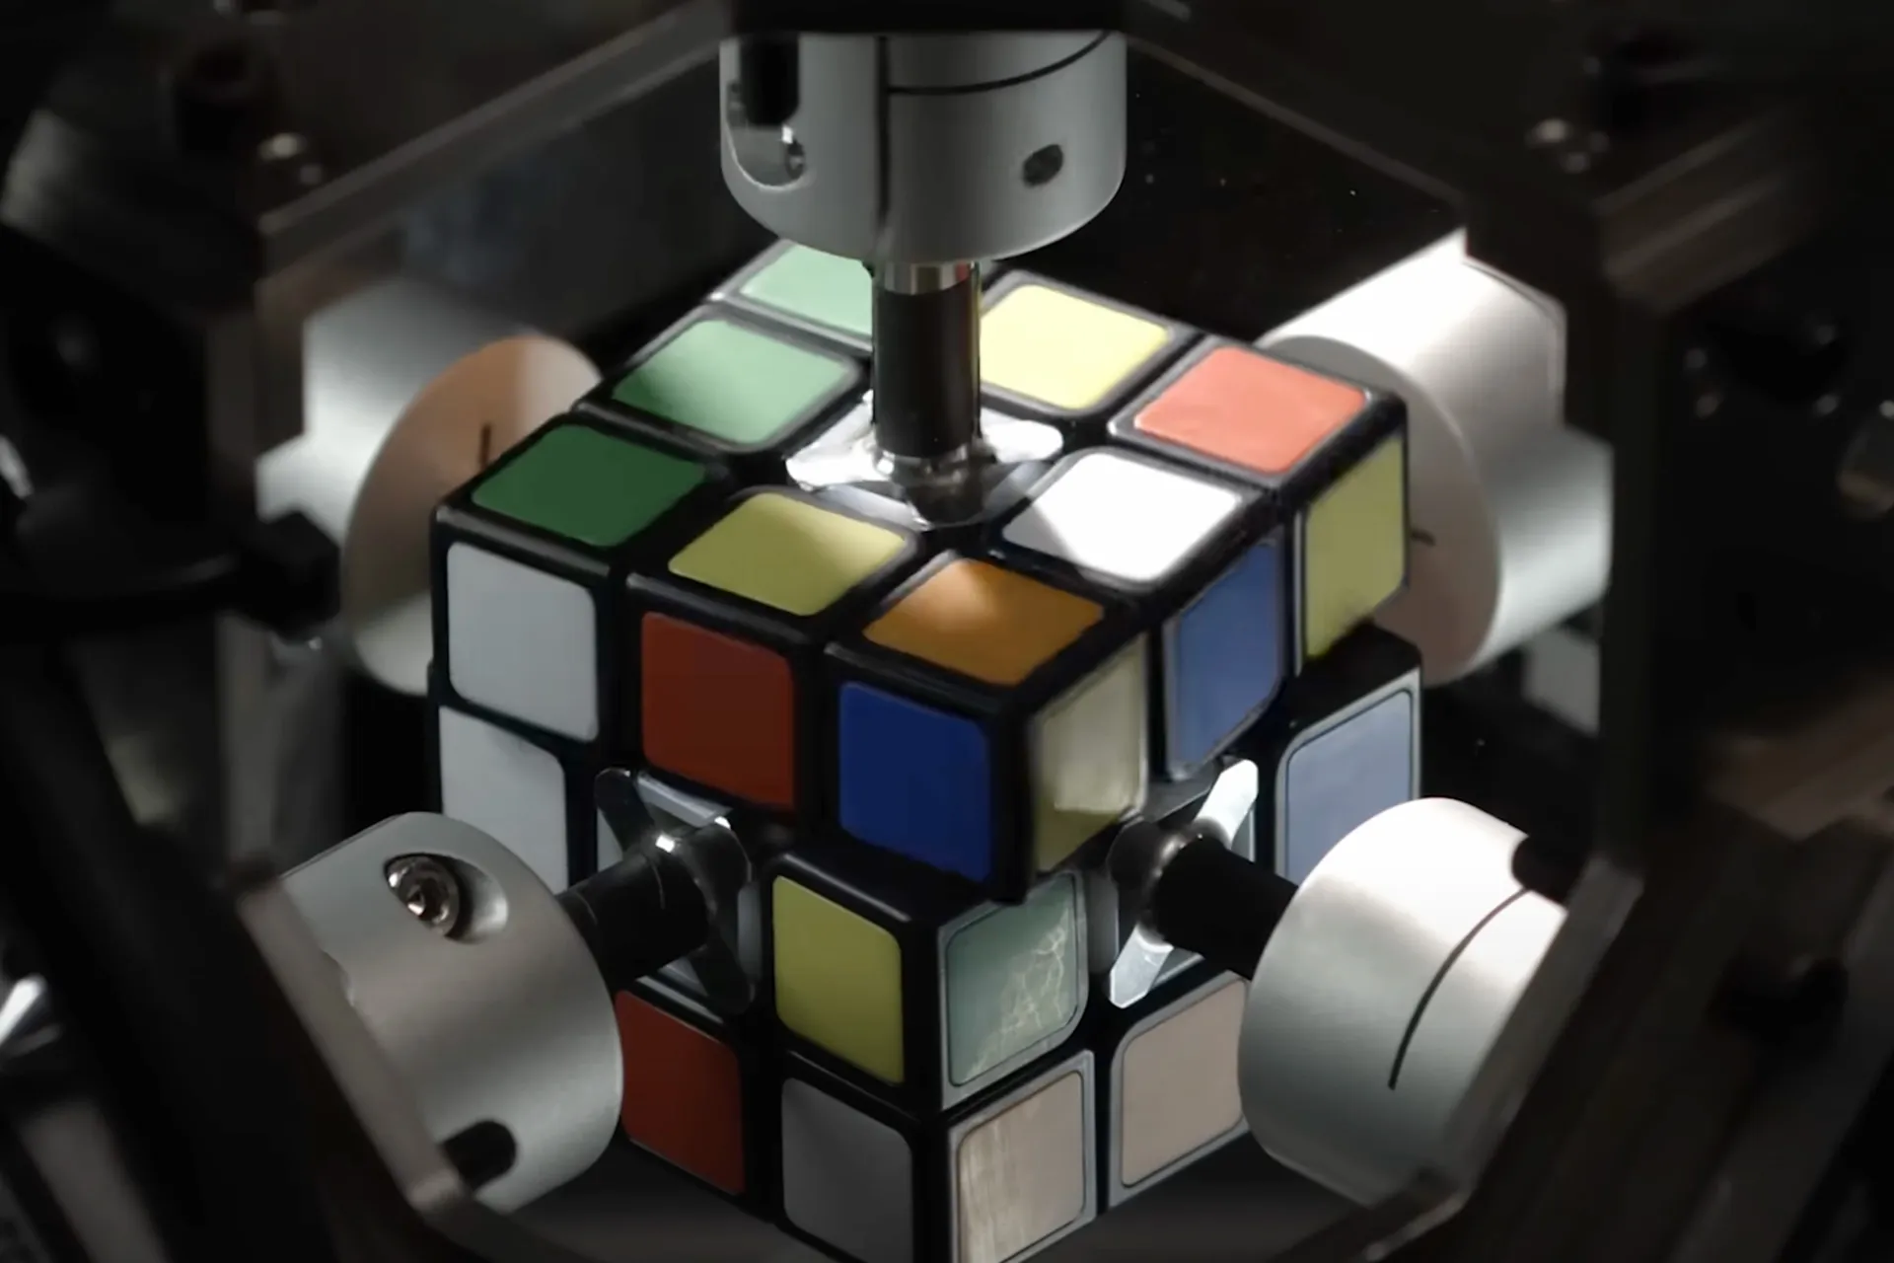
Figure 3: CUBEMOSTER

Solving the Rubik’s cube with deep reinforcement learning and search
In this research, they created an artificial intelligence capable of solving the Rubic’s Cube without the need to study human solutions. It solves the cube in 20 moves, but it is merely a program that does not moves a real cube, this research is purely theoretical, our project is practical, and the cube will be moved by a real robot.
DeepCubeA works by training a deep neural network to approximate a function known as a cost-to-go function, which estimates the number of moves required to get from any given state to the solution state. Because learning from random play is impossible, training cases are generated by starting the model from the goal state and taking random moves backward, allowing the model to learn solutions for an increasingly difficult set of cases.

After training is complete, this estimated function is used as a heuristic within a weighted A* search algorithm to find efficient solution paths for the cube. DeepCubeA is able to solve all test cases 100% of the time, finding the shortest path to the solution in approximately 60.3% of cases for the cube, and much higher rates for other combinational puzzles such as number puzzles (15 puzzles, 24 puzzles) and the "Lights Out" game.

DeepCubeA is built on the foundations of DeepCube, a reinforcement learning model using Monte Carlo Tree Search (MCTS) combined with policy and value functions, an approach similar to the famous AlphaZero technique that excels at games like chess and Go. However, studies have shown that MCTS in the context of synthetic puzzles sometimes produces very long solutions with high execution times, while DeepCubeA offers significant improvements in terms of solution speed and short path length. [4]
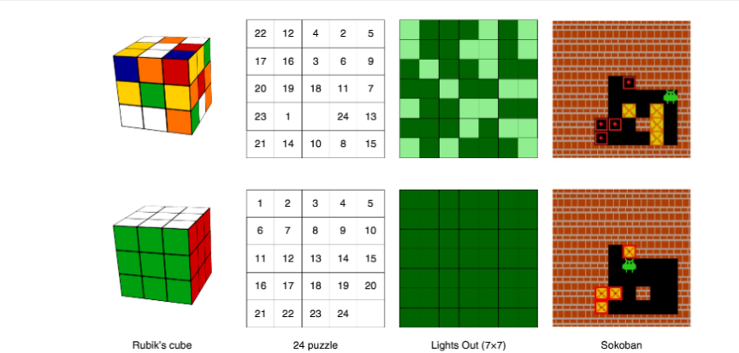
Figure 4: SOLVING THE RUBIK’S CUBE WITH DEEP REINFORCEMENT LEARNING AND SEARCH

Aspect | AI-Based Methods (CNN, BFS) | Deep Learning/Reinforcement Learning (DeepCubeA) | Other Robotic Implementations (with CFOP, DFS) | Our Method (Kociemba’s Algorithm with Servo Motors)
Algorithm Type | Heuristic/Learning-based | Reinforcement Learning | Hybrid (Manual/AI) | Deterministic Mathematical Algorithm
Solution Optimality | Sub-optimal; varies based on training data | Often optimal or near-optimal | Varies by selected algorithm | Highly optimal (fewer than 21 moves typically)
Computation Time | Slow (requires multiple iterations) | Fast in theory but not always applicable in real-time robotics | Moderate (depends on implementation) | Very fast; well-suited for embedded systems like Raspberry Pi
Hardware Requirements | High-end GPUs for training | High computational power during training phase | Microcontrollers (Arduino, etc.) | Low-to-moderate (Raspberry Pi + servos)
Integration with Robotics | Complex; requires additional hardware and software layers | Limited to simulation or high-cost prototypes | Possible, but often complex setups | Easy integration with motors and sensors
Real-Time Execution | Challenging due to latency | Mostly theoretical/simulation-based | Some real-world implementations exist | Fully implemented and functional in real time
Learning Dependency | Requires large datasets and training | Requires simulated environments and long training | Mixed use of learned and manual strategies | No learning required; purely algorithmic
Customization & Adaptability | High adaptability through retraining | High potential but limited in real-world use | High interactivity and customization | Less adaptive but highly reliable and predictable
Implementation Complexity | High | Very High | Medium to High | Medium; well-documented libraries available
Error Rate / Success Rate | Medium to high error rate depending on model accuracy | Near-perfect in simulation (100% success reported) | Varies with mechanical reliability | Aimed at ≥90% success rate in physical manipulation
Educational Value | Good for AI/ML understanding | Excellent for research-level exploration | Good for interdisciplinary learning | Strong foundation in embedded systems, vision, and control
Project Suitability | Not ideal for undergraduate senior project | Too advanced/research-focused | Feasible but may require more components | Ideal fit for scope, timeline, and resources
Related works and ours table show
- CHAPTER 3: METHODS AND MATERIALS
  - System Design and Architecture

Project overview:
For our senior project, we’re developing a robot that can automatically solve a 3x3 Rubik’s Cube. It uses computer vision to detect the cube’s colors, servo motors to move its faces, and an algorithm to find the solution. The system includes a Raspberry Pi, two cameras, six servos, and a mechanical base. The solving algorithm is Kociemba’s, and it’s implemented using Python.
The project was divided into four main subsystems:
- Image Acquisition and Processing
We will mount two cameras on opposite sides of the cube to capture all six faces by rotating the cube when necessary. We will then process the images using OpenCV in Python to detect and map each square’s color

- State Recognition and Solving Algorithm
The recognized cube colors are converted into a string format that represents the cube state. This state is passed into the Kociemba algorithm, which returns an optimized sequence of moves to solve the cube.
- Hardware Control and Cube Manipulation
Six servo motors are mounted around a custom base to grip and rotate each face of the cube. The Raspberry Pi generates PWM signals to control the motors based on the solution sequence.
- System Coordination and Execution
A control program on the Raspberry Pi orchestrates the full process: capturing images, interpreting the cube state, computing the solution, and commanding the servo motors to execute the moves.

Detailed System Architecture:
The overall system design of the Cube Mind Rubik's Cube solver integrates hardware and software components to achieve autonomous cube solving. At the core of the system is a Raspberry Pi 4, which serves as the central processing unit responsible for coordinating all operations. Two USB cameras are used for image acquisition, capturing the current state of the Rubik’s Cube from different angles. Six servo motors control the physical rotation of each face of the cube based on movement instructions generated by the system. The mechanical base securely holds the cube and motors in place, ensuring precise manipulation. Software components include OpenCV for image processing and color detection, the Kociemba's algorithm for computing optimal solution sequences, and a custom Python script that manages the entire workflow from initialization and image capture to solution execution via motor control. This integrated approach enables the robot to detect the cube's scrambled state, calculate an efficient solving sequence, and physically manipulate the cube to reach the solved state autonomously.
Main Control Script Manages sequencing, timing, and coordination between vision, algorithm, and motor control.

system workflow summary:
- Startup: The system initializes all motors and cameras.
- Image Capture: Cameras take pictures of the cube; faces are turned as needed.
- Color Mapping: The software identifies the color of each sticker.
- Solving: The current state is input into the Kociemba algorithm, which returns a solution.
- Execution: Servo motors rotate the cube step-by-step according to the solution sequence.
- Completion: The cube reaches the solved state, and the system halts or resets.

workflow flowchart:
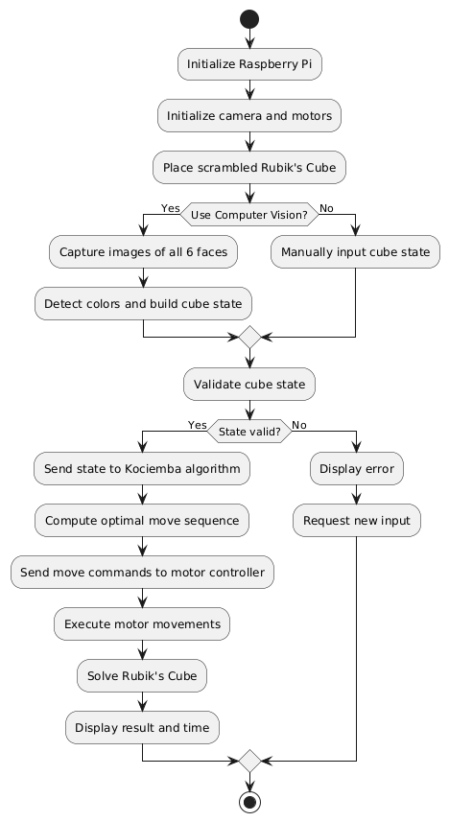
Figure 5 WORKFLOW FLOWCHART

UseCase diagram:
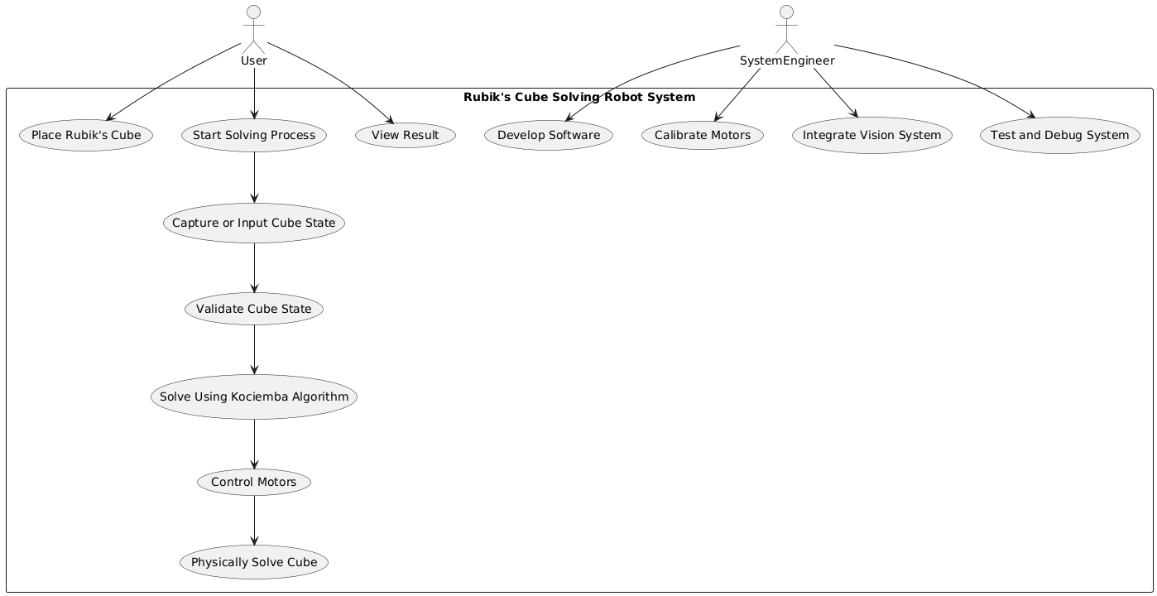
Figure 6 USECASE DIAGRAM

sequence diagram:
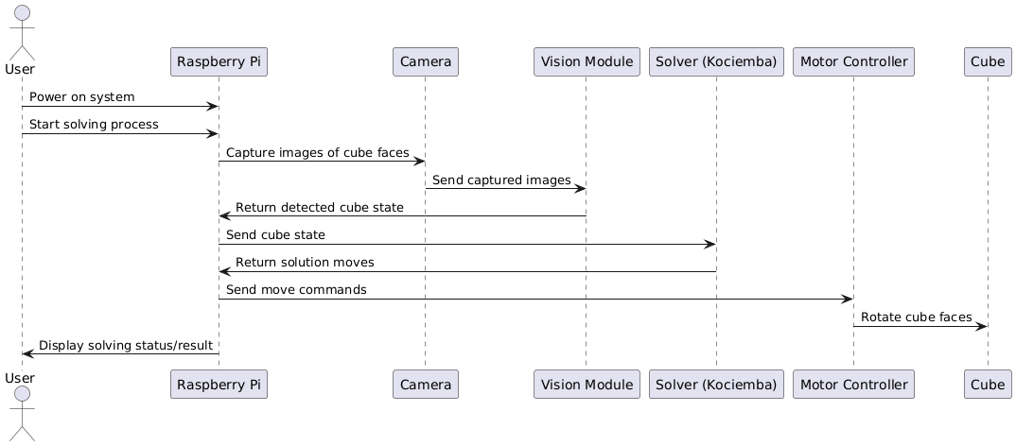
Figure 7 SEQUENCE DIAGRAM
  - System Design and Components

SYSTEM DESIGN
- Raspberry Pi, Central processing unit running Python code, controlling all components.
- USB Cameras, Capture images of the Rubik’s Cube from different angles.
- Servo Motors, Control cube face rotations (one for each face).
- Power Supply, Supplies appropriate voltage to motors and Raspberry Pi.
- Custom Base and Grippers, Holds the cube in place and mounts all motors securely.
- Software Components,
- OpenCV, Used for image capture and color detection.
- Python with Kociemba's Module, Converts detected cube state to a solving sequence.
- GPIO Library, Sends PWM signals from Raspberry Pi to servo motors.

View #1 ( Top ) :
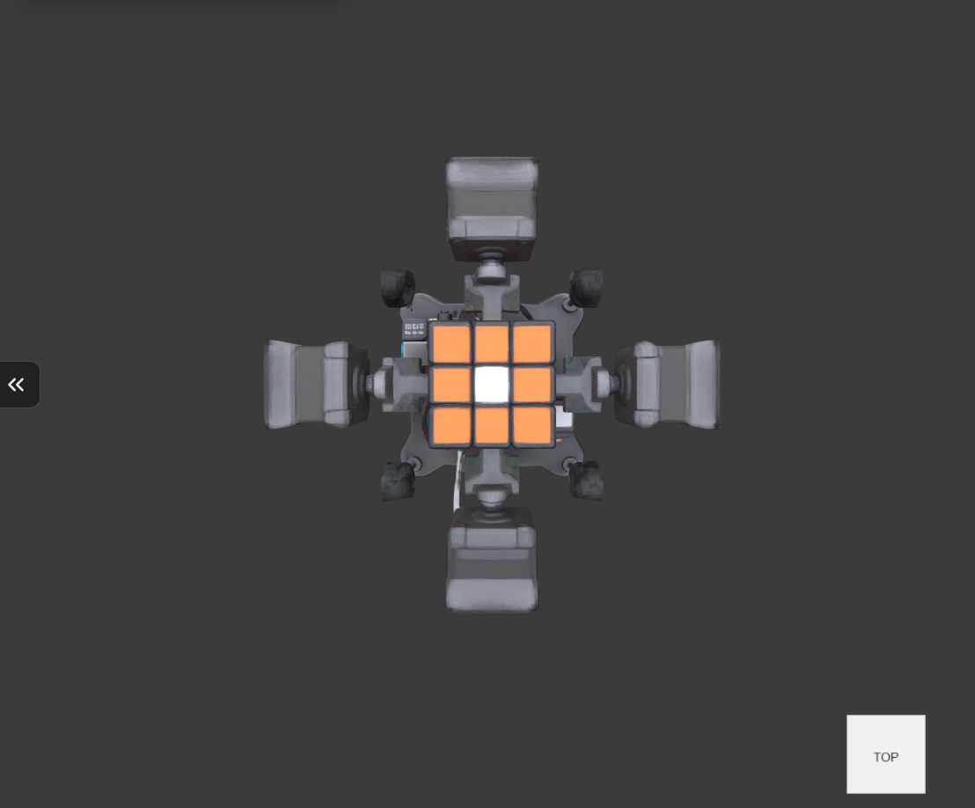
Figure 8 APPROXIMATE IMAGE FROM ABOVE

View #2 :
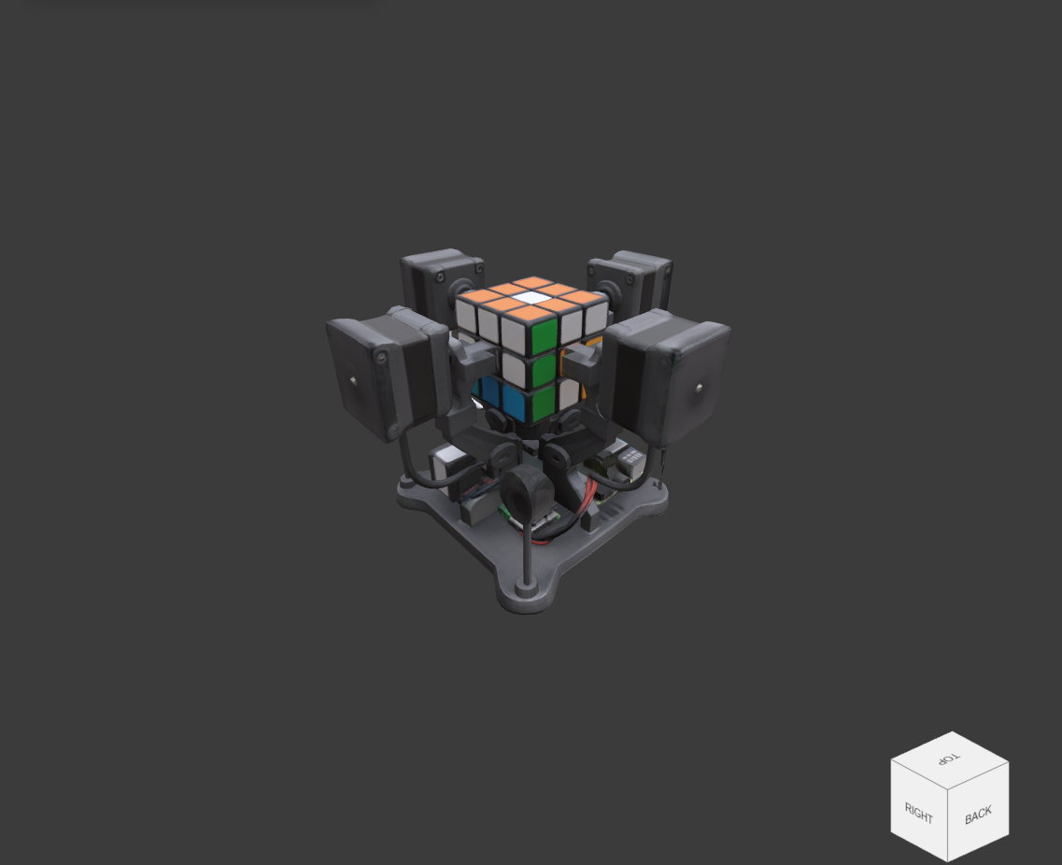
Figure 9 APPROXIMATE SIDE VIEW 1

View #3 :
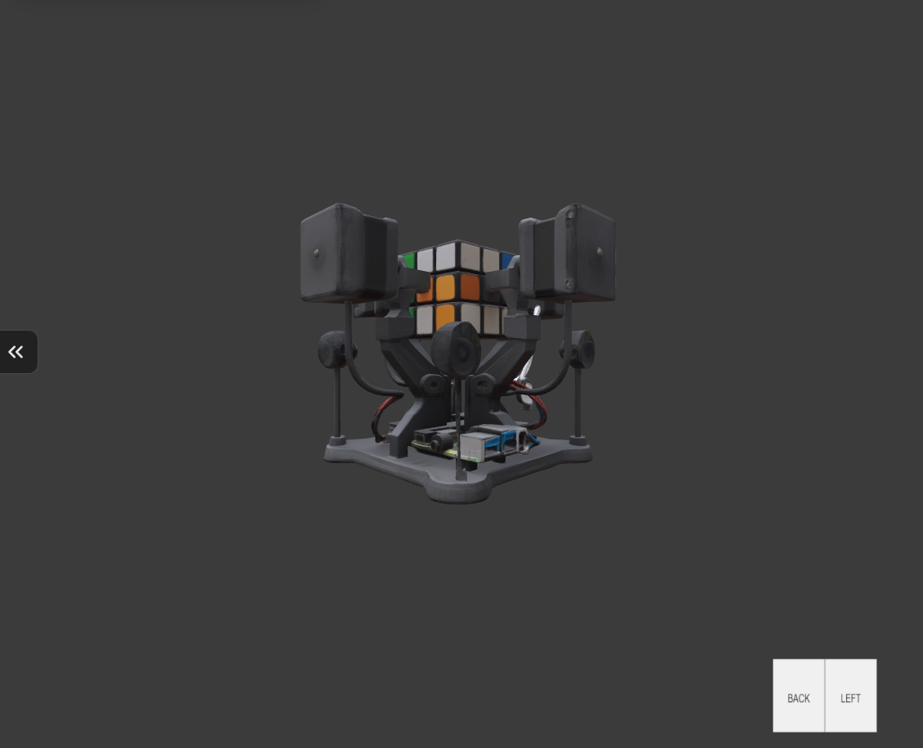
Figure 10 APPROXIMATE SIDE VIEW 2

View #4 :
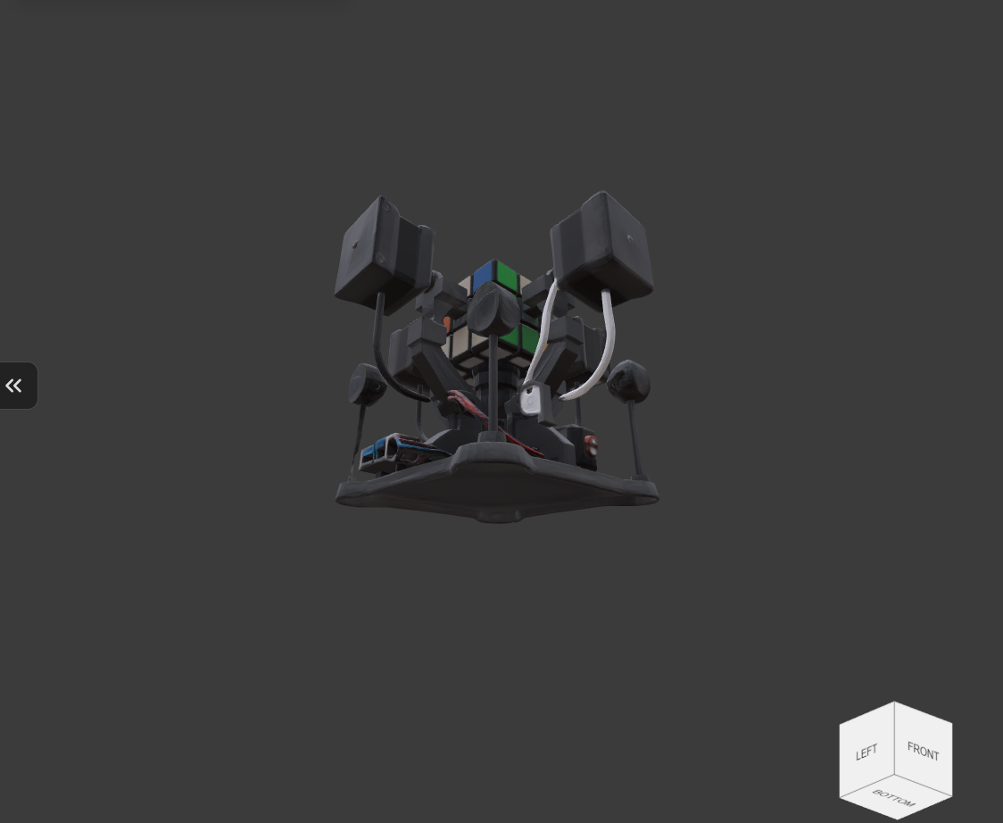
Figure 11 APPROXIMATE IMAGE FROM BELOW

Note: the Design needs the sixth camera to read the upper (top) face of the cube to be completed.

project components:
- Raspberry Pi:
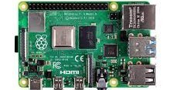
Figure 12 RASPBERRY PI
The Raspberry Pi acts as the central processing unit, coordinating all hardware and software operations of the Rubik’s Cube solving robot.
It captures images from the two cameras, processes them using computer vision, and determines the cube's color configuration.
Based on the solved sequence from the Kociemba's algorithm, the Raspberry Pi sends control signals to the servo motors to rotate the cube accordingly.
- Cameras :
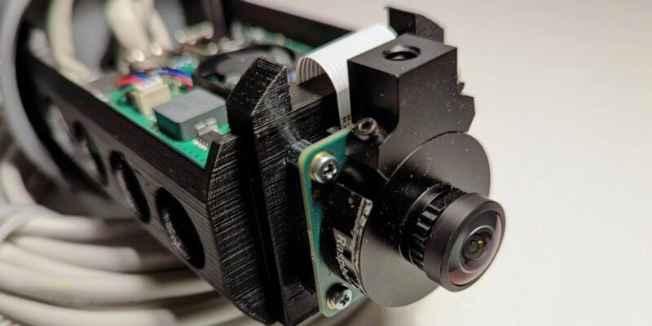
Figure 13 CAMERAS
To determine each square's location and color, the cameras take high-resolution pictures of each face of the Rubik's Cube.
The Raspberry Pi receives the captured images and uses OpenCV for image processing and color recognition.
Before solving, the system can accurately reconstruct the cube's current state thanks to precise visual data from the cameras.
- Servo Motors:
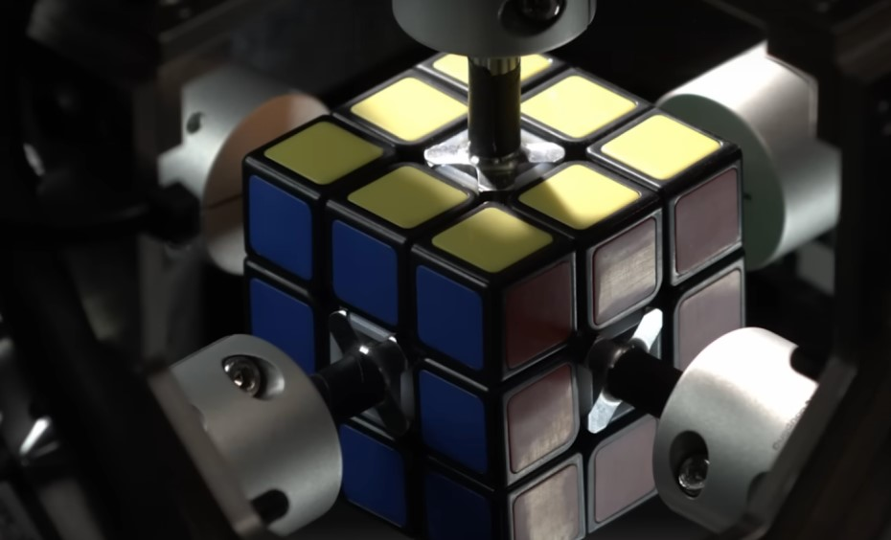
Figure 14 SEVRO MOTORS
Commands from the Raspberry Pi cause the servo motors to physically rotate the Rubik's Cube's faces.
With precise angular movement, each of the six servo motors is in charge of grasping and rotating a particular cube face.
They carry out the algorithm-calculated solution steps, enabling the robot to solve the cube on its own.
- Base :
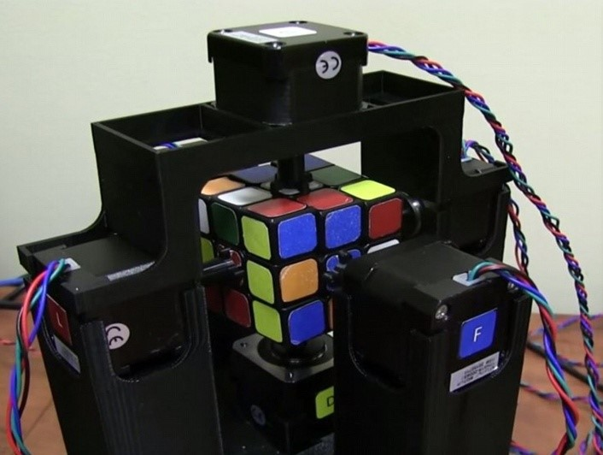
Figure 15 BASE OF THE PROJECT DESIGN
The base supports the mounting of all six servo motors and offers a sturdy framework for safely holding the Rubik's Cube.
When the motors rotate each face, it makes sure the cube stays correctly aligned throughout rotation, avoiding slippage or misalignment.
Additionally, the base aids in the orderly arrangement of the parts, which makes the system small, strong, and simpler to put together and maintain.

software
Kociemba's algorithm:
The Rubik's Cube can be solved from any jumbled state by using the Kociemba algorithm to determine an effective and ideal series of moves.
After image processing has identified the cube's current state, the algorithm uses this state as input in string format to produce a step-by-step solution.
The servo motors are then able to carry out each move and solve the cube by converting the output of the Kociemba algorithm into motor control commands. [5]

  - Design Specifications, Standards and Constraints

Design specifications:
Hardware Requirements:
- Mechanical frame supporting
- Standard 3×3 Rubik's cube compatibility
Performance Specifications:
- Cube solving time ≤30 seconds
- Success rate ≥ 90% across 20 test attempts
- Color detection accuracy ≥ 95% under standard indoor lighting
- Motor rotations : 90 , 180 , 270 or -90

applicable standards:
Hardware Standards:
- USB 2.0/3.0: Used for connecting the camera to the Raspberry Pi for image capture.
- GPIO Standards: Relevant for configuring and interfacing with input/output pins on the Raspberry Pi.
- PWM Standards: Used to control servo motors for precise rotational movement.
Software Development Standards:
- Python Enhancement Proposals (PEP): Follows PEP 8 and PEP 257 for clean, readable, and maintainable Python code.
- OpenCV Standards: Computer vision library implementation for image processing
Communication Standards:
- I2C Protocol: Inter-integrated circuit communication for sensor interfaces
- UART Standards: Universal asynchronous receiver transmitter for serial communication
Open Source Standards:
- Linux Kernel Standards: Raspberry Pi OS (Debian-based) compliance
- GNU General Public License (GPL): Open source software licensing
- Python Software Foundation License: Python interpreter and libraries
- OpenCV BSD License: Computer vision library usage
Quality and Safety Standards:
- RoHS Directive: Ensures that electronic components used in the project are free from hazardous substances.

Design constraints:
- Only solves 3*3 cube
- Recognizes specific colors (white, yellow, green, blue, red, orange)
  - Design Alternatives

Solver algorithm
Our initial alternative design for the project involved developing our own algorithm to solve the cube. However, we ultimately decided to implement Kociemba’s algorithm instead, as it offers greater efficiency and reliability. Creating a new algorithm from scratch would have required significantly more time and effort without providing any substantial benefits essentially reinventing the wheel.

Arduino
The second design alternative was to use an Arduino board to handle the project. However, we replaced it with a Raspberry Pi mainly because the Raspberry Pi performs image reading and processing from the camera much faster and more efficiently. Unlike the Arduino, the Raspberry Pi has a full operating system, supports high resolution camera modules, and can run advanced image processing libraries like OpenCV. Additionally, the Raspberry Pi allows for easier integration of software components such as the solving algorithm, vision system, and control logic, all in one platform. These capabilities make it a better fit for our project's real time requirements.

number of cameras
The third alternative design we considered involved the number of cameras used in the system. Initially, we planned to use six cameras one for each face of the cube. However, we later decided to use only two cameras positioned at the corners of the cube, allowing each camera to capture three faces simultaneously. This approach significantly reduced the project's cost and complexity while still providing sufficient visual coverage for our needs.

data mining algorithms
The final design alternative involved our choice of motor. Initially, we planned to use a stepper motor, but we ultimately decided to switch to a servo motor. This decision was based on performance, as servo motors are significantly faster than stepper motors, aligning with our project's main goal of achieving high speed operation. Additionally, servo motors offer better position and angle control, resulting in smoother and more precise movements. They are also more energy efficient, require simpler driving circuitry, and have faster response times.
  - System Analysis and Optimization
The development of the Cube Mind Rubik's Cube solver involved a multi-faceted approach to system analysis and optimization, addressing various components critical to its autonomous operation. The primary analyses focused on the efficiency and reliability of the computer vision system, the precision and speed of the mechanical manipulation system, and the performance of Kociemba's algorithm within the embedded Raspberry Pi environment.

Computer Vision System Analysis:
Initial analysis of the computer vision system centered on its ability to accurately detect and interpret the colors of the Rubik's Cube faces under varying lighting conditions.

Mechanical Manipulation System Analysis:
The mechanical system, responsible for physically rotating the cube faces, underwent rigorous analysis to ensure precision, speed, and reliability. This involved evaluating the choice of motors, the design of the gripping mechanism to prevent slippage, and the overall structural stability of the robot, In addition to choosing a smooth moving cube that is easy to move without difficulty.

Kociemba's Algorithm Implementation and Performance Analysis:
Kociemba's algorithm, chosen for its efficiency in finding solutions with a low number of moves.

- CHAPTER 4: RESULTS AND DISCUSSIONS
  - Results

Summarize the results and draw conclusions based on those results. Detailed results (e.g., printouts) can be placed in the Appendix to improve readability of the report. experimental results.
  - Discussions

Discuss your result that obtains in above section.

To be completed in senior II

- CHAPTER 5: Project Management
  - Tasks, Schedule and Milestones
The figure below shows Gantt chart which represents the schedule for the project. It shows how the tasks were divided into the semester period

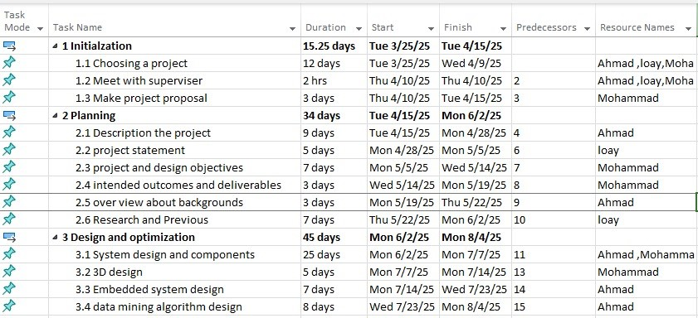

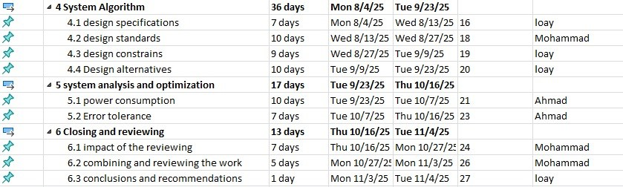



  - Resources and Cost Management
We tried to make our project work in the best possible way at the lowest possible cost without a decrease in performance. The table below shows the components we need and the price for each component according to global price.
Table 5.1 Sample table to fill in total cost of senior project items:
Item | #Unit | Unit Cost | Subtotals | comments
Raspberry Pi 4 (4GB RAM) | 1 | 55$ | 55$ | Main controller
Camera | 2 | 20$ | 40$ | Image capture
Servo Motors (MG996R) | 6 | 5$ | 30$ | For face rotation
Power Supply | 1 | 15$ | 15$ | For Pi and motors
SD Card (32GB) | 1 | 8$ | 8$ | For storage
Jumper Wires & Breadboard | 1 set | 7$ | 7$ | Electrical connections
Base | 1 | 5$ | 5$ | Base for Rubik`s and motors
Rubik’s Cube | 1 | 5$ | 5$ | Test object
Total | 165$

  - Lessons Learned
In this project we learned several lessons from the beginning of it. We have learned how to manage time effectively to deal with unexpected situations. How to build team and distribute the work between us so that everyone does his/her job perfectly. Make sure to have meetings with supervisor to give us feedback so we improved our project continually.
Also we learned some technical things.one of it is how to analysis system and dived it to make sure of all details. How to write document in way make deal with changes easy.

- CHAPTER 6: Impact of the engineering solution
Sustainability consideration and constraints includes economic, environmental, and social (equity) aspects that need to be evaluated and taken into account in project research and development. There is a strong relationship between these three pillars of sustainability. These need to be considered and incorporated in this section with a discussion on their design constraint and the positive and negative effects of the project within this scope.
  - Economical, Societal and Global
Economics (cost) impact: should consider, when relevant,
- Prototype design and production cost, including the manner in which production cost can be reduced, when applicable.
- Device cost in mass production, including materials, operations, supports etc.
- Cost saving of the product should be considered when appropriate. For example, energy savings compared with the use of other products, water saving, reduction in operation cost, etc.
- Tax incentives to be considered towards final product cost. For example, renewable energy and energy efficient products tax incentives, carbon footprint reduction, etc.
- Environmental aspects, such as availability of resources, may affect the product cost and therefore price and their market vulnerability.
Social impact of the product: when relevant, please consider
- How can the developed product impact people lives. Is it a positive or negative impact?
- What community or personal needs does it address?
- Is the product going to change consumption patterns?
- Is the product automating a task currently preformed manually and therefore might impact employment?
- Does the product create new jobs or fields?
- Safety aspects and health concerns
- Regulation constraints that address social and environmental concerns

  - Environmental and Ethical
Environmental impact of the product: when relevant, please consider
- Increase or reduction in emissions obtained through modifications in processes that emit greenhouse gasses (GHG) or products that do so.
- Change in consumption or use patterns, which effect the environment such as use of water, food, energy, wood, etc. (positive or negative affect).
- Reliance on resources that are scarce (such as precious material) or abundant. For examples, some fuel cells technologies use rare material while other use abundant ones. This will have an impact on the availability of these materials as well as their prices.
- Project production and operation effect on natural resources availability and competition on the planet resources. Considering their availability in nature and the impact of their consumption on the balance of nature.
- Environmental regulation

  - Other Issues

- CHAPTER 7: CONCLUSIONS and RECOMMENDATIONS
  - Summary of Achievements of the Project Objectives

Draw conclusions about the level of success of your work. Did you substantially meet your objectives? What did you learn in the process?
  - New Skills and Experiences Learnt

  - Recommendations for Future Work
This is one of the most important sections in the Final Report, at least for those who may pick up where you left off. Knowing what you know now, given the same problem, what would you do if you had it to do all over again? Understanding that problems of significance are rarely if ever solved perfectly the first time, what would you suggest as the next step toward finding the answer?

REFERENCES
[1] Research article, "Research article," 30 3 2022. [Online]. Available: https://www.nature.com/articles/s42256-019-0070-z

[2] Newspaper article, "Click-Whir-Flash Robot Solves Rubik’s Cube," 30 3 2022. [Online]. Available: https://www.pacificu.edu/magazine/click-whir-flash-robot-solves-rubiks-cube

[3] An-Najah University, "A project from An-Najah University," 2024. [Online]. Available: https://repository.najah.edu/items/b5633e81-d21a-4537-85b7-f58da39e4072

[4] Project GitHub, "AI Rubik’s Cube Solver," 15 2 2025. [Online]. Available: https://github.com/chenanton/ai-rubiks-cube-solver?tab=readme-ov-file#background

[5] Kociemba, H., "A Two-Phase Algorithm for Solving the Rubik's Cube," 1992. [Online]. Available: http://kociemba.org/

[6] Rokicki, Kociemba, Davidson, and Dethridge, "The Diameter of the Rubik’s Cube Group is Twenty," 15 2 2025. [Online]. Available: https://doi.org/10.1007/s00454-013-9510-8

APPENDICES

Appendix A:

Appendix B:

Appendix C:

